Western Australian Certificate of Education  
Mid Year Course Examination, 2010

Question/Answer Booklet

|  |  |  |  |  |  |  |  |  |
| --- | --- | --- | --- | --- | --- | --- | --- | --- |
| **Student Number** : In figures: |  |  |  |  |  |  |  |  |

In words: ____________________________________

____________________________________

**HUMAN BIOLOGICAL SCIENCE Stage 2**

**Time allowed for this paper**  
Reading time before commencing work: ten minutes  
Working time for paper: two and a half hours

**Materials required/recommended for this paper  
*To be provided by the supervisor***This Question/Answer Booklet

Multiple-choice Answer Sheet

Two 4-page Answer Booklets

**To be provided by the candidate**Standard Items: pens, pencils, eraser, correction fluid, ruler, highlighters

Special items: non-programmable calculators satisfying the conditions set by the Curriculum Council for this course

**Important note to candidates**No other items may be taken into the examination room. It is **your** responsibility to ensure that you do not have any unauthorised notes or other items of a non-personal nature in the examination room. If you have any unauthorised material with you, hand it to the supervisor **before** reading any further.

**Structure of this paper**

|  |  |  |  |  |  |
| --- | --- | --- | --- | --- | --- |
| Section | Number of questions available | Number of questions to be answered | Suggested working time (minutes) | Marks available | Percentage of exam |
| Section One: Multiple-choice | 25 | 25 | 30 | 50 | ~30 |
| Section Two:  Short Answer | 9 | 9 | 90 | 80 | 50 |
| Section Three:  Extended Answer | 3 | 2 | 40 | 30 | ~20 |
|  |  |  |  |  | 100 |

**Instructions to candidates**

1. Please ensure that you write your student number in the spaces provided on this Question/Answer Booklet, the Multiple Choice Sheet and all Standard Answer Booklets.
2. The rules for the conduct of Western Australian external examinations are detailed in the *Year 12 Information Handbook 2010*. Sitting this examination implies that you agree to abide by these rules.
3. Answer the questions according to the following instructions.

Section One: Answer all questions on the separate Multiple Choice Answer Sheet provided. For each question shade the box to indicate your answer. Use only a blue or black pen to shade the boxes. If you make a mistake, place a cross through that square, do not erase or use correction fluid, and shade your new answer. No marks will be given if more than one answer is completed for any question.

Section Two: Write your answer in the spaces provided in this Question/Answer Booklet.

Section Three: Write your answers in the Standard Answer Books.

1. At the end of the examination, place your Standard Answer Booklets and Multiple Choice Answer Sheet inside this Question/Answer Booklet.

**Section One: Multiple-choice 30% (50 marks)**

This section has 25 questions. Answer all questions on the separate Multiple Choice Answer Sheet provided. For each question shade the box to indicate your answer. Use only a blue or black pen to shade the boxes. If you make a mistake, place a cross through that square, do not erase or use correction fluid, and shade your new answer. Marks will not be deducted for incorrect answers. No marks will be given if more than one answer is completed for any question.

Suggested working time for this section is 30 minutes

1. On the following diagram of the heart, where would you expect to find the sino-atrial node?



1. A
2. B
3. C
4. D
5. The active site of the enzyme molecule:
6. is the location where the enzyme combines with the substrate.
7. will attach to any substrate placed with the enzyme.
8. requires activation energy to bind to the substrate.
9. can never be altered in shape.
10. Natural killer cells circulate throughout the body as part of the immune system’s surveillance against cancer. On detecting a cancer cell, the natural killer cell will phagocytose the rogue cell and destroy it using packets of digestive enzymes. Which of the following organelles would you expect to be abundant in a natural killer cell?
11. Centrioles
12. Lysosomes
13. Nuclei
14. Flagella
15. Metabolism can be described as:

(a) the sum of all chemical reactions in the body

(b) anabolic reactions that produce energy

(c) anaerobic and aerobic respiration

(d) catabolic reactions that release energy.

1. Urea is a waste that is excreted from the body. Urea is formed by the process of:
   1. glycolysis
   2. proteolysis
   3. deamination
   4. anabolism.
2. Which of the following correctly describes the flow of blood through the heart?
3. Bicuspid valve ⭢ right ventricle ⭢semilunar valve ⭢pulmonary artery
4. Tricuspid valve ⭢left ventricle ⭢semilunar valve ⭢pulmonary artery
5. Bicuspid valve ⭢ left ventricle ⭢semilunar valve ⭢aorta
6. Tricuspid valve ⭢right ventricle ⭢semilunar valve ⭢aorta
7. The right ventricle of the heart pumps:
   1. oxygenated blood to the rest of the body
   2. deoxygenated blood to the right atrium
   3. deoxygenated blood to the lungs
   4. oxygenated blood to the right atrium.
8. Which of the following statements is INCORRECT regarding the use of a placebo when testing a new drug or treatment?
9. The placebo should look identical and be administered in the same manner as the drug being tested so the control group don’t realise they are not taking the drug.
10. The group receiving the placebo are not expected to show an improvement in their condition.
11. The group receiving the placebo should have a different result compared to the experimental group to determine the change is due to the treatment being administered.
12. The placebo can be used in medical treatment trials only.
13. Chemical processes in cells produce wastes which must be constantly removed. Why is it necessary for wastes to be removed from cells?
14. Wastes may cause damage to the cell membrane
15. Build up of wastes would cause cells to lose water by osmosis
16. Most waste products of cells are insoluble and would use up energy
17. Wastes change the balance of chemical substances inhibiting cell processes

Questions 10, 11 and12 refer to the following information:

As part of a study of human physiology, a scientist used an exercise bicycle and while controlling all other variables, tested a human subject to determine how heart beat changes during exercise and recovery. The results are given in the table below.

In Test A, the subject pedalled at 240 revolutions per minute. He could not continue after 8 minutes and stopped, feeling totally exhausted.

In Test B, after resting for an hour, the same subject then pedalled the cycle at 100 revolutions per minute until he was stopped after 20 minutes, despite feeling able to continue.

|  |  |  |  |  |  |
| --- | --- | --- | --- | --- | --- |
| TEST A [240 cycles/min] | | | TEST B [100 cycles/min] | | |
|  | Time [minutes] | Heart rate  [beats per minute] |  | Time [minutes] | Heart rate  [beats per minute] |
| At rest | 0 | 78 | At rest | 0 | 78 |
| Cycling | 2 | 150 | Cycling | 2 | 146 |
| 4 | 164 | 4 | 158 |
| 6 | 174 | 6 | 162 |
| 8 | 178 | 8 | 164 |
| Recovery | 10 | 180 | 10 | 165 |
| 12 | 176 | 12 | 168 |
| 14 | 172 | 14 | 172 |
| 16 | 168 | 16 | 174 |
| 18 | 162 | 18 | 176 |
| 20 | 156 | 20 | 176 |
| 22 | 150 | Recovery | 22 | 120 |
| 24 | 142 | 24 | 104 |
| 26 | 134 | 26 | 100 |
| 28 | 124 | 28 | 96 |
| 30 | 102 | 30 | 93 |
| 32 | 80 | 32 | 85 |
| 34 | 78 | 34 | 78 |
| 36 | 78 | 36 | 78 |

1. In terms of chemical reactions taking place within the subject’s muscle cells, the most accurate explanation for not being able to continue beyond 8 minutes in Test A while he was able to continue cycling for 20 minutes in Test B is
   1. In Test A the subject relied on anaerobic respiration for energy.
   2. In Test B the subject relied on anaerobic respiration for energy.
   3. In Test B the subject relied on the partial breakdown of glucose.
   4. In Test A the subject relied on the complete breakdown of glucose.
2. In the experiment which of the following would improve the reliability of results?

i Measure heart rate more accurately.

ii Increase the number of subjects from one to ten.

iii Repeat the experiment ten times.

iv Measure body temperature as well as heart rate.

* 1. i only
  2. i, ii and iii only
  3. ii and iii only
  4. i, ii, iii and iv

1. In a cell, the reactions for aerobic respiration occur in the
   1. cytoplasm and release ADP
   2. mitochondria and release carbon dioxide, water and ATP
   3. cytoplasm and release 36 molecules of ATP
   4. mitochondria and require 36 molecules of ATP
2. Which of the following correctly identifies the digestive enzyme with its substrate and products?

|  |  |  |  |  |
| --- | --- | --- | --- | --- |
|  | **Enzyme** | **Location** | **Substrate** | **Product** |
| (a) | Amylase | Oesophagus | Starch | Disaccharides |
| (b) | Pepsin | Small intestine | Polypeptides | Peptides |
| (c) | Lipase | Stomach | Lipids | Fatty acids + glycerol |
| (d) | Peptidases | Small intestine | Polypeptides | Peptides |

1. During a typical cardiac cycle of 0.8 seconds, the ventricles spend how much time in diastole?
2. 0.2 seconds
3. 0.3 seconds
4. 0.4 seconds
5. 0.5 seconds
6. Angina affects which part of the body?
7. Lungs
8. Kidneys
9. Heart
10. Pancreas
11. Which of the following lists has an anabolic process followed by a catabolic process?

|  |  |  |
| --- | --- | --- |
|  | **Anabolic process** | **Catabolic process** |
| (a) | Respiration | Protein synthesis |
| (b) | Protein synthesis | Fat digestion |
| (c) | Anaerobic respiration | DNA replication |
| (d) | Anaerobic respiration | Aerobic respiration |

1. Which relationship listed below is correct?
   1. Mitochondria release energy for cell transport
   2. Ribosomes break down materials imported by the cell
   3. The endoplasmic reticulum packages materials for export from the cell
   4. The Golgi body is the site of protein synthesis by the cell
2. Down syndrome is caused by a process called non-disjunction. This occurs during meiosis when both members of a pair of chromosomes are pulled into one cell by the spindle, rather than the pair being separated. During which phase of meiosis are the pairs normally separated?

(a) telophase

(b) metaphase

(c) prophase

(d) anaphase

1. Which of the following play an important role in the clotting of blood?
   1. leukocytes
   2. platelets
   3. erythrocytes
   4. lymphocytes
2. The formation of urine by the nephrons of the kidneys involves three major processes. The correct order of these processes is:
3. Secretion, reabsorption and glomerular filtration
4. Reabsorption, glomerular filtration and secretion
5. Glomerular filtration, reabsorption and secretion
6. None of the above
7. The function of alveoli is to
   1. provide a large gas exchange surface.
   2. warm up the air before it moves into the body.
   3. filter microorganisms from the inhales air.
   4. support the lungs.
8. The hormone adrenaline regulates the flow of blood in the following way:
9. it causes the stroke volume of the heart to decrease
10. it causes vasodilation in the skeletal muscles
11. it causes the sinoatrial node to decrease the heart rate
12. it causes dilation of the blood vessels to the stomach and intestines during exercise to increase metabolism
13. The mucosa of the stomach refers to the:
14. substance that is secreted to protect the stomach wall
15. lining of the stomach
16. enzyme responsible for protein digestion
17. acid secreted by the gastric glands
18. The main sites of mechanical digestion are
19. mouth and large intestine
20. mouth and stomach
21. stomach and small intestine
22. small intestine and large intestine
23. Structures called villi are found on the surface of the small intestine. Which of the following statements about intestinal villi is INCORRECT?
24. They provide a high surface area for nutrient absorption.
25. They contain specialised blood capillaries known as lacteals.
26. The cells on their surface are covered with tiny folds called microvilli.
27. They are about 1mm in length.

**Section Two: Short answer 50% (80 marks)**

This section has nine (9) questions. Answer all questions. Write your answers in the spaces provided.

Suggested working time for this section is 90 minutes.

**Question 26**

Students were asked to design an investigation that determined what factors affected enzyme activity. They decided that they would investigate the effect of substrate concentration on enzyme activity. They used the enzyme catalase, which is found in yeast. Catalase works to increase the rate of decomposition of hydrogen peroxide into water and oxygen.

The students added 6cm3 of hydrogen peroxide to 3cm3 of yeast. As soon as they added the hydrogen peroxide to the yeast, a gas syringe bung was added to the test tube and they timed how long it took to collect 20 cm3 of oxygen gas. They then repeated the procedure varying the concentration of the hydrogen peroxide each time.

They then repeated this experiment two more times.

The following table shows the results they obtained from their trials.

|  |  |  |  |  |
| --- | --- | --- | --- | --- |
| **Hydrogen peroxide concentration (%)** | **Time taken (seconds)**  **to collect 20 cm3 oxygen gas** | | | **Average Time taken**  **(seconds)** |
|  | Trial 1 | Trial 2 | Trial 3 |
| 4 | 46.3 | 45.3 | 49.1 |  |
| 8 | 17.4 | 18.0 | 18.9 |  |
| 10 | 17.5 | 16.3 | 18.1 |  |
| 12 | 13.5 | 14.5 | 12.2 |  |
| 16 | 9.3 | 10.1 | 8.4 |  |
| 20 | 9.0 | 9.4 | 8.9 |  |

1. Complete the missing column of the table. *[1 mark]*
2. Graph the results on the grid provided on the following page. *[5 marks]*

Question 26b continued.

1. State the hypothesis that the students were testing. *[1 mark]*
2. What was their independent variable? *[1 mark]*
3. What was their dependent variable? *[1 mark]*
4. Name two variables that were controlled. *[2 marks]*
5. Based on the results collected what conclusions can be drawn about the effect of substrate concentration on enzyme activity? *[2 marks]*

**Question 27**

An artificial cell (see figure below), made from a semi‑permeable membrane and filled with a water solution, was placed in a beaker containing a different solution. The membrane was permeable to water and the smaller sugar molecules, glucose and fructose, but was impermeable to the disaccharide, sucrose.

**Environment**

0.01M sucrose

0.01M glucose

0.01M fructose

**The Cell**

0.03M sucrose

0.02M glucose

0.00M fructose

1. Which solute/s will show net diffusion into the cell? *[1 mark]*

1. Which solute/s will show net diffusion out of the cell? *[1 mark]*

1. In which direction will there be a net movement of water and what effect will that have on the size of the artificial cell? *[2 marks]*
2. Describe the features of an actual cell membrane that would allow the movement of water, glucose and fructose into the cell. *[4 marks]*

**Question 28**

Complete the table below by writing in a scientific word that best matches the description in the left hand column. *[7 marks]*

|  |  |
| --- | --- |
| The type of graph that would be suitable for displaying the growth of a baby over a two year period. |  |
| The main chemical compound that forms the bilayer of a cell membrane |  |
| A type of endocytosis that mainly involves taking liquid into a cell |  |
| The first phase in the breakdown of glucose |  |
| A tightly coiled thread of DNA that can be seen with a light microscope |  |
| A small compound consisting of two simple sugars joined together |  |
| The organelle directly responsible for making protein |  |

**Question 29**

Structure of the respiratory system.

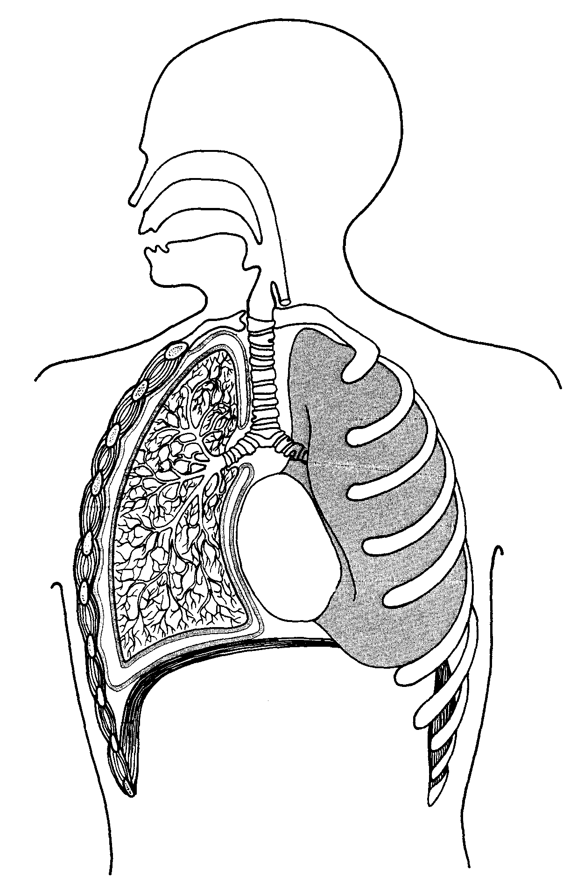

1

2

(air sacs)

(a) Name structures 1 and 2 and explain how each one is suited to its function.

*[4 marks]*

Structure 1

Structure 2

(b) Describe the mechanics behind the process of expiration (breathing out).

*[4 marks]*

(c) People who smoke cigarettes are risking major damage to their health. Name two structures of the respiratory system that suffer damage from cigarette smoking and explain how this damage can impact on the process of breathing. *[4 marks]*

**Question 30**

Use the diagram below to answer the following questions.

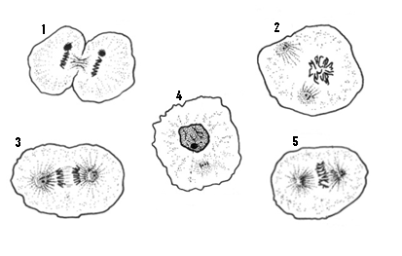

1. Using the numbers from the diagram, list the stages of mitosis in the correct order. *[1 mark]*
2. What significant event takes directly after Stage 5. *[1 mark]*
3. Describe how the event you stated in (b) effects the outcome of mitosis.

*[1 mark]*

The graph below shows the changes in the amount of DNA in a cell during one mitotic cycle.

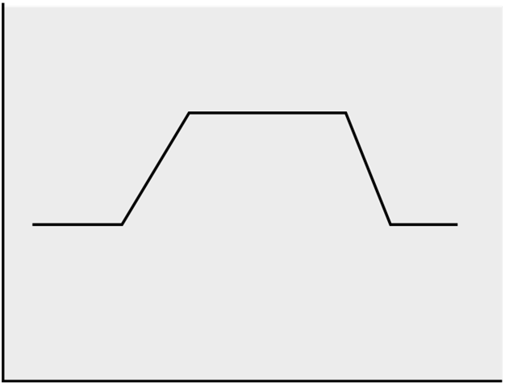

**Changes in the Amount of DNA during Mitosis**

Time (minutes)

Amount of DNA

(arbitrary units)

**A**

**B**

**C**

**D**

**E**

(d) Which stage, or stages, of mitosis occur between:

A-C _________________________________________________________

*[1 mark]*

D-E _________________________________________________________

*[1 mark]*

(e) If the amount of DNA present in a cell at metaphase in mitosis is 10 units, how much DNA will be present in each nucleus immediately following telophase?

_______________________________ *[1 mark]*

Explain your answer.

*[2 marks]*

**Question 31**

The following diagrams show structures of the human digestive system.

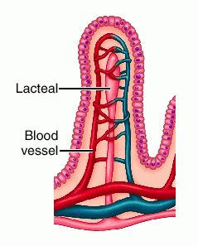

1.

**3.**

Villus

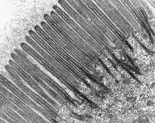

2.

Highly magnified border of one epithelial cell

(a) Name and describe the role of structures 1, 2 and 3 in the absorption of digested food substances. *[6 marks]*

Structure 1

Structure 2

Structure 3

(b)Describe the role of bile in the process of digestion. *[2 marks]*

**Question 32**

Use the information in the table below to answer the following questions.

|  |  |  |
| --- | --- | --- |
| **Part of the body** | **Rate of blood flow (mL/min)** | |
|  | **When resting** | **When exercising** |
| Skeletal muscle | 1050 | 12500 |
| Digestive system (stomach, intestines, liver) | 1310 | 600 |
| Kidneys | 1100 | 600 |
| Brain | 700 | 710 |
| Skin | 320 | 1900 |
| Heart muscle | 200 | 750 |
| Other organs | 340 | 400 |

Data from Saladin, K ed. *Anatomy and Physiology:* The Unity of Form and Function. 3rd edn. New York: McGraw-Hill, 2004.

1. Calculate the person’s cardiac output when resting.

___________________________________________________________ *[1 mark]*

1. Using your answer in (a), calculate the person’s stroke volume if they had a resting heart rate of 72 bpm.

___________________________________________________________ *[1 mark]*

1. From the table, which part of the body is most involved in exercise? Give a reason to support your answer.

*[1 mark]*

1. Why is there almost no change in blood flow to brain between rest and exercise?

*[1 mark]*

1. Clearly label the systemic and pulmonary circulations on the diagram below.

*[2 marks]*

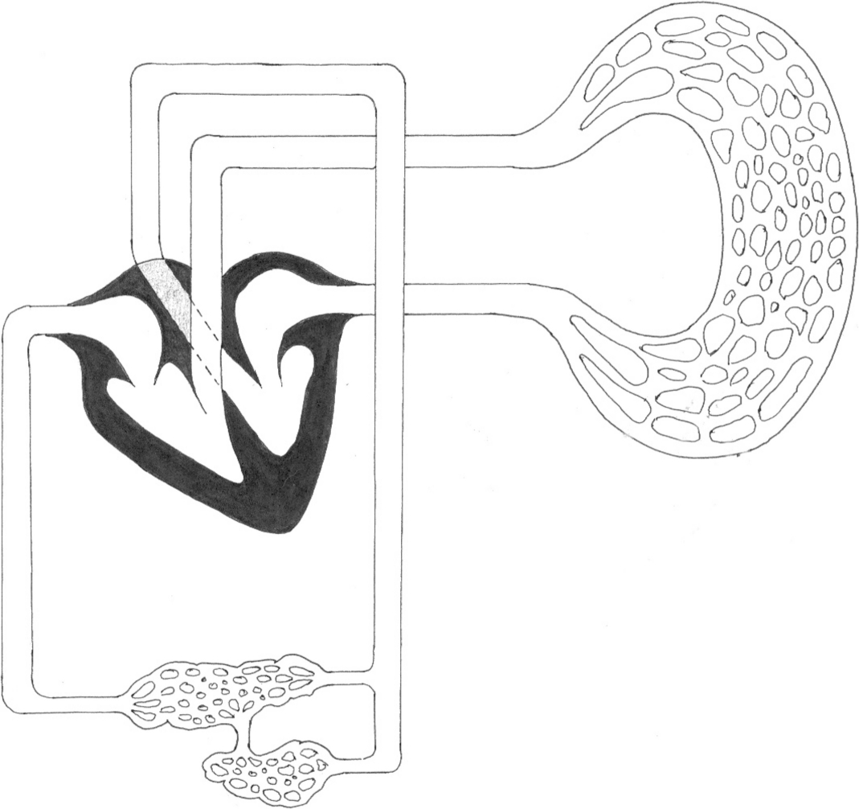

Lungs

Deoxygenated Blood

Oxygenated Blood

Liver

Small Intestine

1. Using two different colours, shade the appropriate sections to illustrate deoxygenated and oxygenated blood on the above diagram. Complete the two boxes for each corresponding colour next to the diagram. *[2 marks]*
2. The hepatic portal vein directly links the liver with the small intestine. What is the purpose of this blood vessel? *[1 mark]*
3. Explain why the blood in the hepatic portal vein would contain a higher concentration of glucose when compared to a normal vein, but would have the same amount of carbon dioxide. *[3marks]*

**Question 33**

The following diagrams show the macroscopic and microscopic structures in the kidneys.

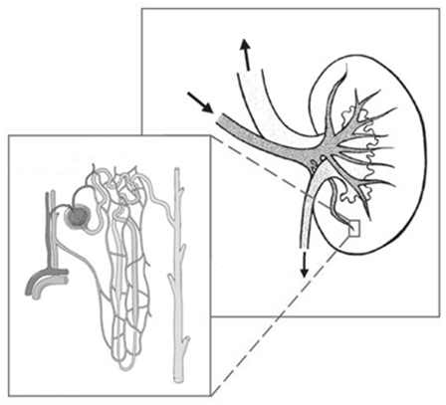

**B** _________

**A** _________

(a) Name Structure A ____________________________________________ *[1 mark]*

Name Structure B ___________________________________________ *[1 mark]*

(b) What is the function of Structure B? *[2 marks]*

(c) List the three main components that make up urine. *[2 marks]*

**Question 34**

## The figure below shows the breathing rate of a person at rest breathing different gas mixtures.



Students drew certain conclusions concerning the data shown in the figure. These conclusions, (a) to (f), are listed in the table below. Complete Columns 1 and 2 in the table as follows:

Column 1 write

S If the conclusion is supported by the evidence.

C If the conclusion is contradicted by the evidence.

N If there is no evidence to support or contradict the conclusion from the figure.

Column 2

If your answer to Column 1 is S or C give evidence from the figure to explain your answer.

If your answer to Column 1 is N, leave the space blank.

|  |  |  |
| --- | --- | --- |
| Conclusion | Column 1 | Column 2 |
| (a) The rate of breathing increases markedly in 6% carbon dioxide |  |  |
| (b) A concentration of more than 6% carbon dioxide is fatal |  |  |
| (c) There is no marked change of breathing rate under any conditions |  |  |
| (d) Temperature is a major factor in increasing the breathing rate |  |  |
| (e) The concentration of carbon dioxide plays an important part in governing breathing |  |  |
| (f) Lack of oxygen is a stimulus to increasing breathing rate |  |  |

*[6 marks]*

**Section Three: Extended answer 20% (30 marks)**

This section contains three (3) questions. You must answer two (2) questions. Write in the Standard Answer Booklets.

Responses could include clearly labeled diagrams with explanatory notes; lists of points with linking sentences; clearly labelled tables and graphs; and annotated flow diagrams with introductory notes.

Suggested working time for this section is 50 minutes.

**Question 35**

1. Identify three organs in the body that benefit from a high surface area. For each organ explain how the high surface area is achieved and also the purpose of the high surface area. *[6 marks]*
2. Describe in detail how the body digests a piece of bread. *[9 marks]*

**Question 36**

The circulatory system plays a vital role in our bodies.

1. Arteries veins and capillaries are blood vessels. Describe two structural features of each. *[6 marks]*
2. Explain how one of the structural features you have described for each of the types of blood vessels helps these blood vessels to carry out their function.

*[3 marks]*

1. Describe how gases are transported in the blood. *[6 marks]*

**Question 37**

1. Sketch a nephron and label it to show each of the key structures that appear in the table below.

*[3 marks]*

1. Discuss the role of the various regions of the nephron in regulating the composition of body fluid. Use data from the table below to support your answer.

*[12 marks]*

### Concentration of Solutes (micrograms / Litre)

|  |  |  |  |  |  |
| --- | --- | --- | --- | --- | --- |
| Solute | Glomerulus | Bowman’s Capsule | Proximal Convoluted Tubule | Distal Convoluted Tubule | Collecting Duct |
| Protein | 5,000 | 5 | 0.3 | 0 | 0 |
| Glucose | 230 | 230 | 19 | 0 | 0 |
| Urea | 55 | 55 | 50 | 54 | 100 |
| Sodium Ion | 440 | 440 | 50 | 53 | 93 |
| Potassium Ion | 600 | 600 | 60 | 95 | 150 |